# *Web Programming I (420-C10-HR)*

# *Lab 13 – Tables and Templates*

Date assigned: Tuesday, November 24, 2015

Date due: **Tuesday, November 24, 2015**

**Learning Objectives**

Upon successful completion of this lab exercise, the student will be able to:

* Understand how to use tables in web pages

To do:

**Lab Set-Up**

1. Copy the C10_L13 zip file from Moodle and unzip it to your H:\420-C10\Labs folder. Rename the folder to **YourUserName_C10_L13**.

**Part A: Dreamweaver Tutorial on Tables**

1. Start Dreamweaver and create a site (manage sites) called “YourUserName L13 A” in your Labs folder of C10 folder on your H drive. Use the directory H:\C10\Labs\YourUserName_C10_L13\part_a to store your files.
2. Click on the Link “Dreamweaver Tutorial 7” on the Moodle page for the course and complete the Dreamweaver Tutorial.

**Part B: Tables**

1. Create a new blank page called hockeyscores.html with the title Hockey Scores. You will read in some scores from a csv file and create a table with those scores.
   1. Create a CSS file called score.css and attach it to the hockeyscores.html file.
   2. Add a style for the <body> with the background colour #FFC and the text colour #006 and the font-family Verdana, sans-serif.
   3. Add a style for the <h2> element so that it is centred horizontally on the page, is padded on all sides by 5 pixels and has a solid border 2 pixels wide along the bottom in colour #006.
   4. Add a style for the table to centre it on the page (set the margin: auto), and a double border 3 pixels wide of colour #006 and has the borders collapsed (border-collapse: collapse)
   5. Add a single style for the td and th tags (td, th) so that they have a padding of 3 pixels on all sides and solid border, 1 pixel wide in colour #006.
   6. Add a style for the tr tag so that the background colour of every second row (even row) has a background colour of #006 and a text colour of #FFC (think pseudo types). You will have to look at the page in LiveView or in the browser to see this working.
   7. Add a tag for the th which is bold, 1.1 em size font and has the text-aligned to the left.
   8. Add a class call ctrcol that has the text-aligned to centre.
   9. Add the text Hockey Scores as a <h2>
   10. Under the heading, import the file File > Import > Tabular Data and import the file scores.csv
   11. Make sure you remove the border setting of 1 (remove do NOT set to 0)
   12. Change the <td> tags in the first row to be <th> tags (you will likely need to work in code to do this).
   13. Select each column with the scores and attach the class ctrcol to it (you REALLY want to do this in design mode and select the entire column). You cannot use <colgroup> or <col/> for this. The ONLY attributes that can be set in a colgroup or col is the border, background, width and visibility. Therefore, you will have to add class=”ctrcol” to each <td> tag that needs to be centred (columns 2 and 4).
   14. The final page should look like Figure 2

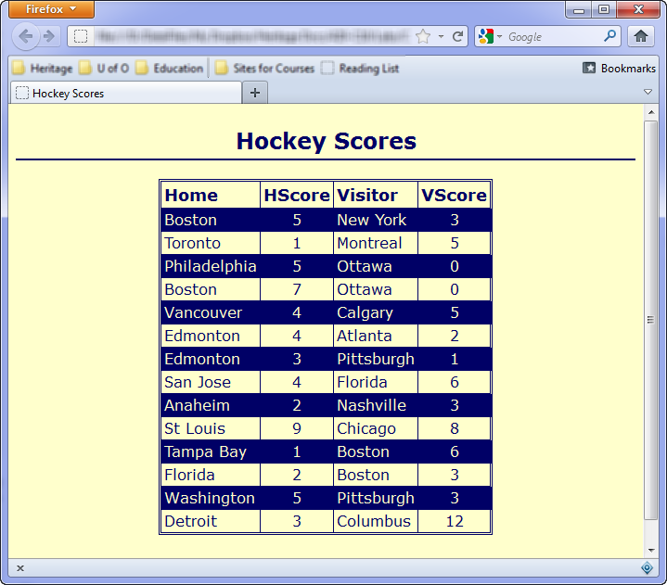

Figure 2: Hockey Score Imported

**Part C – Pacific Trails Resort Case Study**

1. Create a new site in Dreamweaver called Lab 12C. Use the folder H:\C10\Labs\YourUserName_C10_L13\part_c to store your files. This folder should already exist in the folder you copied at the beginning of the lab.
2. Complete Pacific Trails Resort Case Study on pages 376-377 of your textbook.
   1. In step one, I have already copied the files to the part_c folder in the lab folder you copied at the beginning of the lab, so they should be available to you in Dreamweaver if you completed the previous step.

**To submit**

When you have completed the lab exercise, create a zip file of all the files in your L13 folder. Call the zip file YourUserName_C10_L13.zip and copy it to the Moodle page for the class. The zip file must contain:

* All the files required for the websites (html, CSS and image files).